Part 1 – WMS Database Design
Upload a screenshot of your initial database diagram from Lucidchart and your final database diagram from SSMS below.
- Lucidchart Database Diagram:
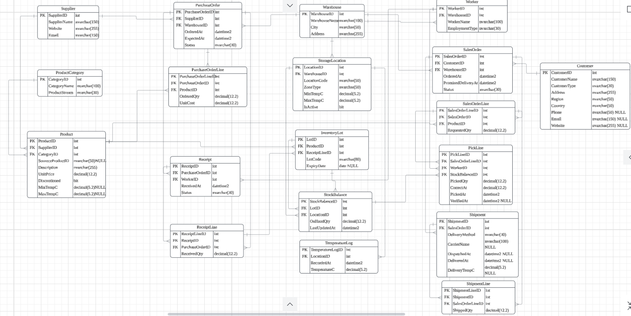
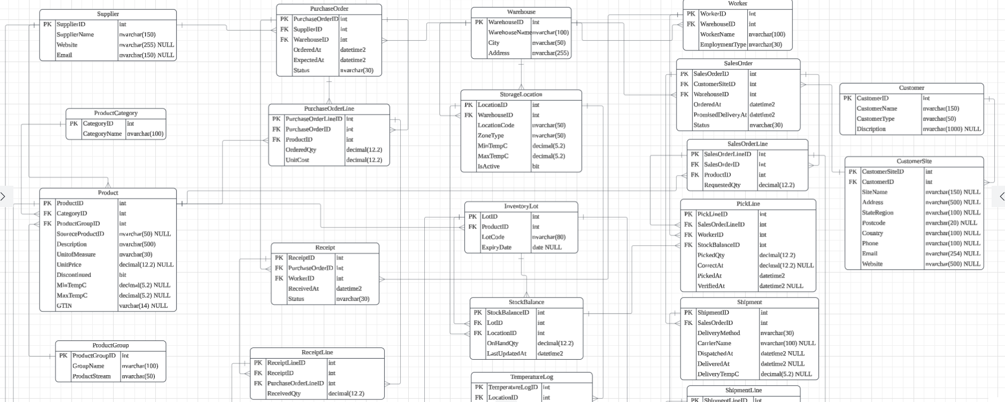
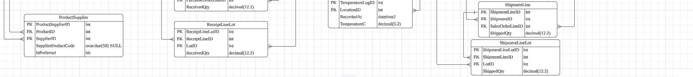
- SSMS Database Diagram:

- Explain the critical thinking underlying your WMS database design including choice of tables and relationships.

Part 2 - DQL Queries
- Screenshots of the four DQL queries from SQL Server along with their outputs:
Queries | Outputs

- Critically analyse the quality of each of your four queries and their relevance to business. If you have used supporting tools such as ChatGPT to help you develop any of your queries, you should explain how these tools were used as evidence of your critical thinking skills. Remember to cite the corresponding webpages.

